PE Enrichment- Half Term 2
Monday | Tuesday | Wednesday | Thursday | Friday
Y8 & Y9 Netball    Mrs Norman  Miss Hudson |   Girls’ Rugby  Mr Hewitt | Y11 & Y12/13 Rugby    Mr Lewis  Mr Hewitt | Y7 Netball  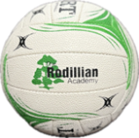  Mrs Norman  Miss Hudson | Basketball    Mr Oxley  Mr Hewitt
Y7 Rugby  Mr Hewitt  Mr Oxley  Mr Naylor | Badminton  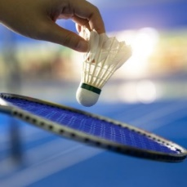  Mr Thomas | Y7, 8 & 9  Boys’ Football    Mr Walker | Y10 Rugby  Mr Hewitt  Mr Naylor  Mr Lewis
Table Tennis    Mr Gee |  |  | Fitness Suite  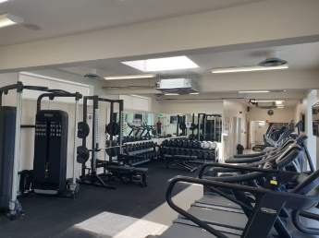  Miss Rudd
Fitness Suite  Miss Rudd |  |  | Y7, 8 & 9  Girls’ Football  Mr Paul
4th Nov- 19th December 2025

