2.4 Questions
Q1.
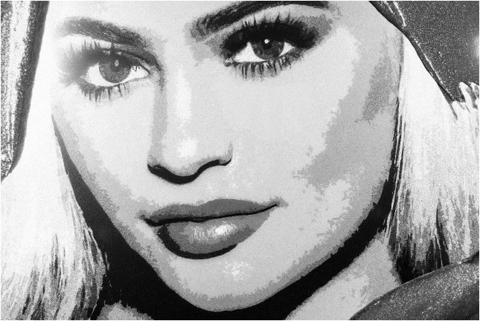
Famous from her role in hit reality television series 'Keeping Up with the Kardashians', 19-year-old Kylie Jenner is now also recognised as a successful teenage entrepreneur in her own right.
Celebrated for her full lips, Kylie Jenner decided to launch a range of lip kits with unique names such as 'Dolce K'. These products sold out within 10 minutes, as her fan base of teenage girls rushed to copy her celebrity look. The success of these products convinced Kylie to start her own internet cosmetics company, Kylie Cosmetics. She has now increased its range of products to include an eye shadow and eyeliner called Kyshadow and Kyliner respectively.
Kylie regularly interacts with her fans and potential customers using social media. Her app (application), which provides make-up and fashion tips, is one of the most downloaded entertainment apps in the UK. Every Kylie Cosmetics product has a launch date and products are only available for a limited period of time, before they sell out. Once the products have sold out, customers may have to wait weeks before the cosmetics are available for sale on the Kylie Cosmetics website again. None of Kylie Cosmetics' products are tested on animals and virtually all of them are suitable for vegans.
(Source: adapted from http://www.vanityfair.com/style/2016/10/kylie-jenner-lip-kits-seed-beauty-colourpop)
Figure 3 shows the ranking of the Kylie Jenner Official App in the UK entertainment iPhone download charts from July to September 2016.
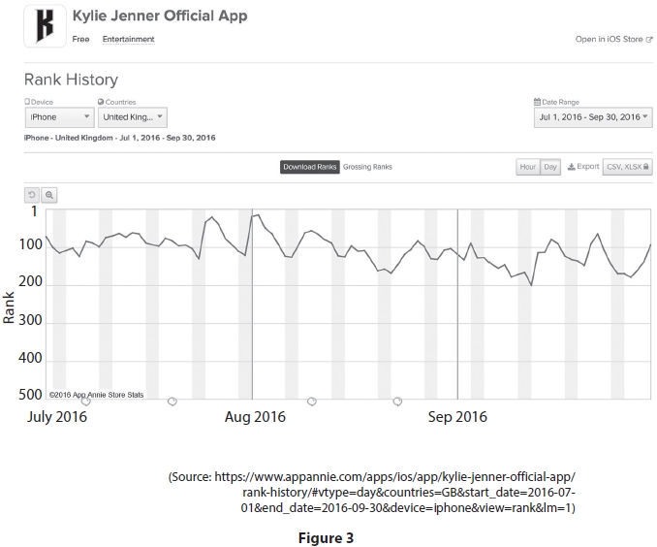
Using Figure 3, identify the month where the Kylie Jenner Official App fell to its lowest ranking in the UK iPhone entertainment download chart.
.............................................................................................................................................
.............................................................................................................................................

(Total for question = 1 mark)

Mark Scheme
Q1.

