  - Questions
Q1.
Explain one possible conflict that can exist between stakeholders of a business.
(3)
.............................................................................................................................................
.............................................................................................................................................
.............................................................................................................................................
.............................................................................................................................................
.............................................................................................................................................
.............................................................................................................................................

(Total for question = 3 marks)

Q2.
Explain one possible objective of employees within a business.
.............................................................................................................................................
.............................................................................................................................................
.............................................................................................................................................
.............................................................................................................................................
.............................................................................................................................................
.............................................................................................................................................

(Total for question = 3 marks)

Q3.
Answer the question with a cross in the box you think is correct . If you change your mind about an answer, put a line through the box and then mark your new answer with a cross .
Which one of the following best defines the term stakeholder?
Select one answer.
A An owner of a private limited company
B Someone with an interest in the success of a business
C Any individual who takes decisions within a business
D An individual who owns shares in a business

(Total for question = 1 mark)

Q4.
Answer the question with a cross in the box you think is correct . If you change your mind about an answer, put a line through the box and then mark your new answer with a cross .
Which two of the following are possible impacts on a small business of lower interest rates?
Select two answers.
A Higher fixed costs
B Lower insurance premiums
C Customers more likely to purchase using credit
D Lower costs of borrowing money
E Increased variable costs due to higher loan repayments

(Total for question = 2 marks)

Q5.
Read the following extract carefully and then answer the question.
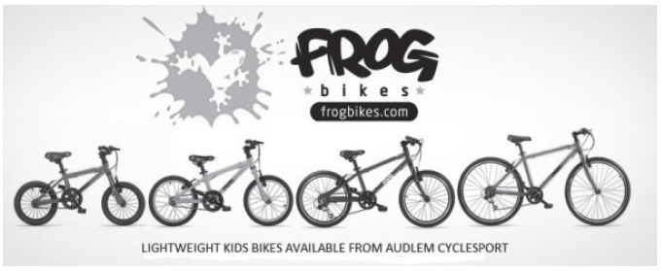
In 2012 Jerry and Shelley Lawson started a new business – Frog Bikes. The aim was to produce lightweight and affordable children's bikes. The company's bikes were designed for children using the latest technology. The bikes are produced in a Chinese factory and sold in the UK and other countries.
The business quickly became successful. By 2016 its bikes were sold in over 700 shops in the UK. It faces competitors such as JE James which sell similar bikes in the UK.
Frog Bikes uses social media to promote its bikes. Figure 2 shows a competition run on the Frog Bikes Twitter account. To enter the competition people needed to follow the business on Twitter.
As a manufacturer and retailer, Frog Bikes has to comply with a large amount of legislation. All bikes meet ISO (International Standards Office) standards. This ensures they are safe for children. Rules include the need for all bikes to be fitted with a chain guard, and for handlebars to be safety checked.
In 2016 Jerry and Shelley decided to increase production to meet the growing demand. They considered expanding the company's Chinese factory, or building a new factory in the UK.
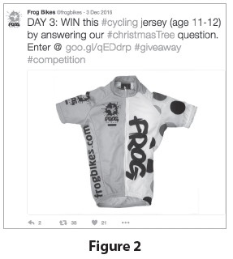
(Source: adapted from http://startups.co.uk/startups-100/2016/8-frog-bikes/)
A retailer selling Frog Bikes bicycles has the following financial information for the month of April.
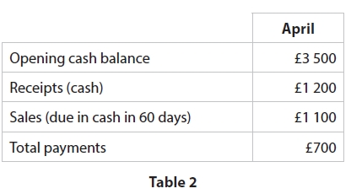
Analyse the impact on Frog Bikes of the legislation it has to comply with when producing and selling its bikes.
.............................................................................................................................................
.............................................................................................................................................
.............................................................................................................................................
.............................................................................................................................................
.............................................................................................................................................
.............................................................................................................................................
.............................................................................................................................................
.............................................................................................................................................
.............................................................................................................................................
.............................................................................................................................................
.............................................................................................................................................
.............................................................................................................................................

(Total for question = 6 marks)

Q6.
Explain one benefit to employees of employment law.
.............................................................................................................................................
.............................................................................................................................................
.............................................................................................................................................
.............................................................................................................................................
.............................................................................................................................................
.............................................................................................................................................

(Total for question = 3 marks)

Q7.
Look at Figures 1 and 2, read the extract carefully, then answer the question.
Analyse the impact on Meringue of allowing customers to order their food online in advance.
(6)
.............................................................................................................................................
.............................................................................................................................................
.............................................................................................................................................
.............................................................................................................................................
.............................................................................................................................................
.............................................................................................................................................
.............................................................................................................................................
.............................................................................................................................................
.............................................................................................................................................
.............................................................................................................................................
.............................................................................................................................................
.............................................................................................................................................

(Total for question = 6 marks)

Q8.
Read the following extract carefully and then answer the question.
In 2012 Jerry and Shelley Lawson started a new business – Frog Bikes. The aim was to produce lightweight and affordable children's bikes. The company's bikes were designed for children using the latest technology. The bikes are produced in a Chinese factory and sold in the UK and other countries.
The business quickly became successful. By 2016 its bikes were sold in over 700 shops in the UK. It faces competitors such as JE James which sell similar bikes in the UK.
Frog Bikes uses social media to promote its bikes. Figure 2 shows a competition run on the Frog Bikes Twitter account. To enter the competition people needed to follow the business on Twitter.
As a manufacturer and retailer, Frog Bikes has to comply with a large amount of legislation. All bikes meet ISO (International Standards Office) standards. This ensures they are safe for children. Rules include the need for all bikes to be fitted with a chain guard, and for handlebars to be safety checked.
In 2016 Jerry and Shelley decided to increase production to meet the growing demand. They considered expanding the company's Chinese factory, or building a new factory in the UK.
(Source: adapted from http://startups.co.uk/startups-100/2016/8-frog-bikes/)
Analyse the impact on Frog Bikes of using social media to promote its products.
.............................................................................................................................................
.............................................................................................................................................
.............................................................................................................................................
.............................................................................................................................................
.............................................................................................................................................
.............................................................................................................................................
.............................................................................................................................................
.............................................................................................................................................
.............................................................................................................................................
.............................................................................................................................................
.............................................................................................................................................
.............................................................................................................................................

(Total for question = 6 marks)

Q9.
Explain one benefit to a small business of using social media as a method of communicating with customers.
.............................................................................................................................................
.............................................................................................................................................
.............................................................................................................................................
.............................................................................................................................................
.............................................................................................................................................
.............................................................................................................................................

(Total for question = 3 marks)

Q10.
Discuss the benefit to a business of using e-commerce.
.............................................................................................................................................
.............................................................................................................................................
.............................................................................................................................................
.............................................................................................................................................
.............................................................................................................................................
.............................................................................................................................................
.............................................................................................................................................
.............................................................................................................................................
.............................................................................................................................................
.............................................................................................................................................
.............................................................................................................................................
.............................................................................................................................................

(Total for question = 6 marks)

Q11.
Read the following extract carefully and then answer the question.
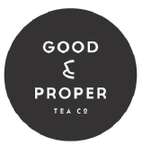
Good and Proper Tea was founded in 2012 by Emilie Holmes. The business website states:
'We source our teas from around the world, from Kenya to India, Japan to China and many more places in between. It is important to us that we know exactly where each tea comes from and who is responsible for harvesting the leaves we buy. We will always share this information with our customers'.
The business started when Emilie converted an old Citroën van (pictured right) into a mobile brew bar. Emilie wanted to expand the business. To achieve this she needed finance.
She decided to raise finance using crowdfunding through the Kickstarter website. 372 individual backers each provided between £1 and £1000. Good and Proper Tea was launched. The first cup of tea was brewed and sold in Shoreditch, London, in 2012.
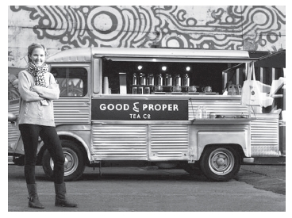
The success of the mobile business led Emilie to plan to open a shop selling the same high-quality teas. Once again she decided to use crowdfunding as her source of finance. This time, using the Crowdcube website, she successfully raised £140,000. The shop was opened in 2016 and is very successful.
As Good and Proper Tea imports its most important ingredient, it is affected by changes in the exchange rate. Recent changes in the value of the pound mean that its costs have increased.
(Source: adapted from http://www.stylist.co.uk/stylist-network/work-life/work-life-emilie-holmes-founder-good-and-proper-tea)
Outline one impact of changing levels of consumer incomes on Good and Proper Tea.
.............................................................................................................................................
.............................................................................................................................................
.............................................................................................................................................
.............................................................................................................................................

(Total for question = 2 marks)

Q12.
Read the following extract carefully and then answer the question.
Good and Proper Tea was founded in 2012 by Emilie Holmes. The business website states:
'We source our teas from around the world, from Kenya to India, Japan to China and many more places in between. It is important to us that we know exactly where each tea comes from and who is responsible for harvesting the leaves we buy. We will always share this information with our customers'.
The business started when Emilie converted an old Citroën van (pictured right) into a mobile brew bar. Emilie wanted to expand the business. To achieve this she needed finance.
She decided to raise finance using crowdfunding through the Kickstarter website. 372 individual backers each provided between £1 and £1000. Good and Proper Tea was launched. The first cup of tea was brewed and sold in Shoreditch, London, in 2012.
The success of the mobile business led Emilie to plan to open a shop selling the same high-quality teas. Once again she decided to use crowdfunding as her source of finance. This time, using the Crowdcube website, she successfully raised £140,000. The shop was opened in 2016 and is very successful.
As Good and Proper Tea imports its most important ingredient, it is affected by changes in the exchange rate. Recent changes in the value of the pound mean that its costs have increased.
(Source: adapted from http://www.stylist.co.uk/stylist-network/work-life/work-life-emilie-holmes-founder-good-and-proper-tea)
To reduce the impact of its rising costs, Good and Proper Tea is considering two options:
Option 1: Buying cheaper ingredients from different suppliers.
Option 2: Charging higher prices for its tea.
Justify which one of these two options Good and Proper Tea should choose.
.............................................................................................................................................
.............................................................................................................................................
.............................................................................................................................................
.............................................................................................................................................
.............................................................................................................................................
.............................................................................................................................................
.............................................................................................................................................
.............................................................................................................................................
.............................................................................................................................................
.............................................................................................................................................
.............................................................................................................................................
.............................................................................................................................................
.............................................................................................................................................
.............................................................................................................................................
.............................................................................................................................................
.............................................................................................................................................
.............................................................................................................................................
.............................................................................................................................................

(Total for question = 9 marks)

Q13.
Explain one impact on a small business of a reduction in government taxation.
.............................................................................................................................................
.............................................................................................................................................
.............................................................................................................................................
.............................................................................................................................................
.............................................................................................................................................
.............................................................................................................................................

(Total for question = 3 marks)

Q14.
Erik Fairbairn started POD Point in 2009. Based in the UK, the business builds and supplies charging systems for electric cars. Erik felt that the demand for such cars was going to grow and saw a business opportunity. POD Point is a way of charging an electric car at home.
Sales were promising and the business decided to expand. In 2014 POD Point raised £1.5 million through the crowd funding site Seedrs. In 2017 it raised a further £1.5 million using CrowdCube website.
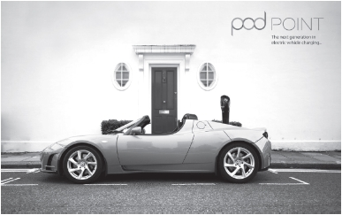
By 2017 the business had over 25,000 customers, many of whom are in other countries. For example, 20% of revenue comes from exports to Norway. The business is affected when the exchange rate changes.
The business uses market research data that suggests that the demand for electric cars will continue to rise. Figures 3 and 4 show examples of market research in the car industry.
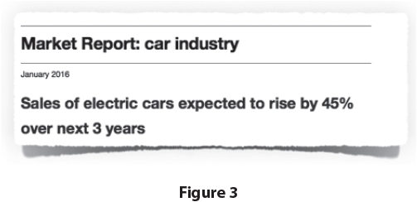
(Source: adapted from http://startups.co.uk/the-entrepreneur-erik-fairbairn-pod-point/)
Figure 4 shows the market share of models of electric cars in selected European countries in 2016.
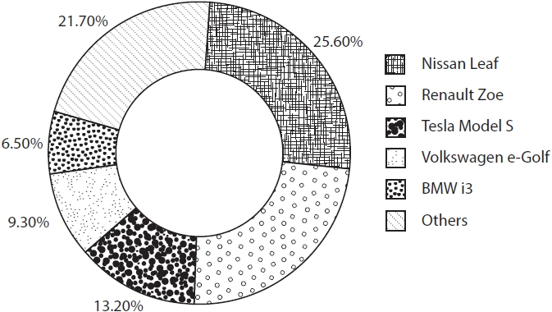
(Source: adapted from https://cleantechnica.com/2016/05/30/topelectric-cars-uk-norway-netherlands-germany-france/)
Figure 4
The UK economic climate is important for POD Point. It is considering two options to reduce the impact of falling UK consumer incomes on sales:
Option 1: Focus on selling to foreign customers.
Option 2: Cut costs of production.
Justify which one of these two options POD Point should choose.
.............................................................................................................................................
.............................................................................................................................................
.............................................................................................................................................
.............................................................................................................................................
.............................................................................................................................................
.............................................................................................................................................
.............................................................................................................................................
.............................................................................................................................................
.............................................................................................................................................
.............................................................................................................................................
.............................................................................................................................................
.............................................................................................................................................
.............................................................................................................................................
.............................................................................................................................................
.............................................................................................................................................
.............................................................................................................................................
.............................................................................................................................................
.............................................................................................................................................

(Total for question = 9 marks)

Mark Scheme
Q1.
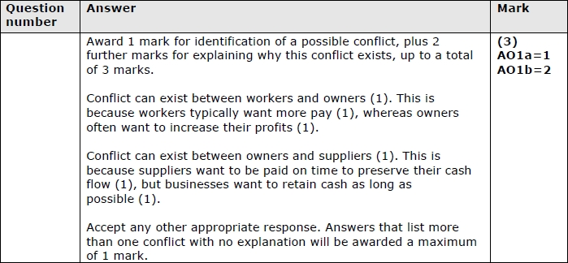

Q2.
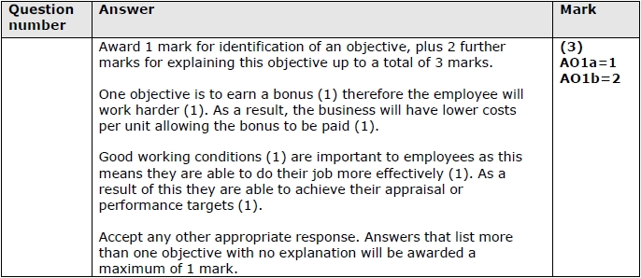

Q3.

Q4.

Q5.
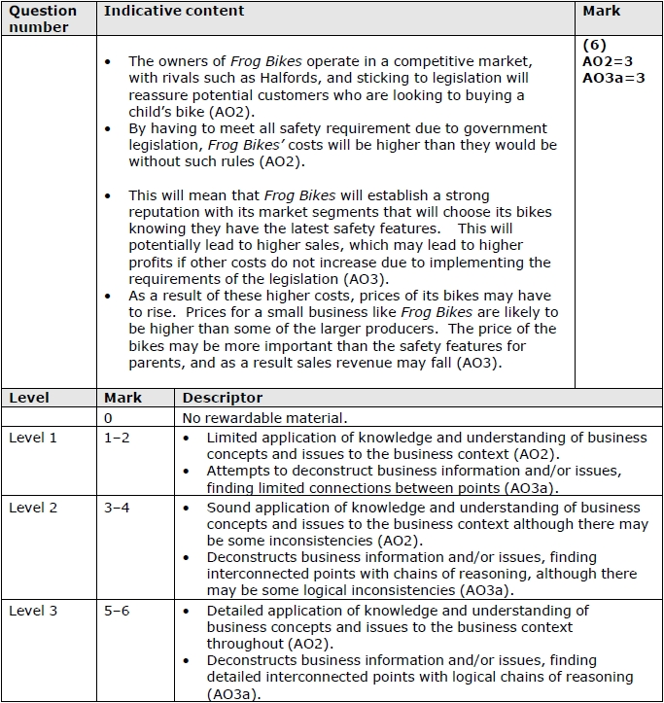

Q6.
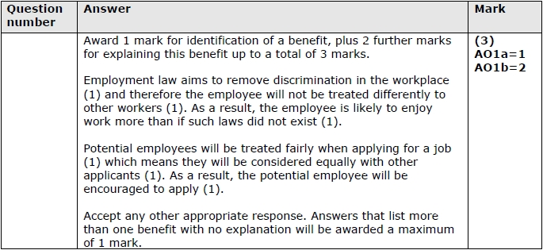

Q7.
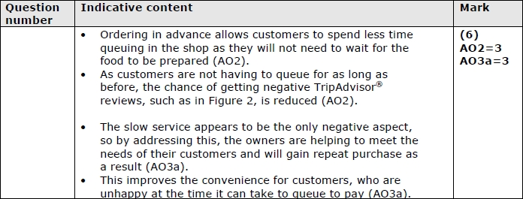
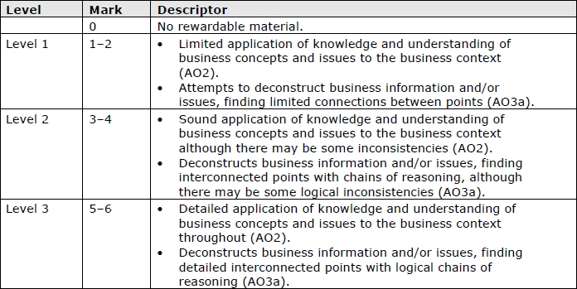

Q8.
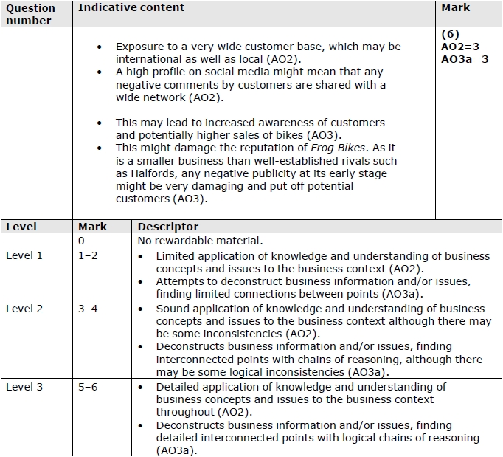

Q9.
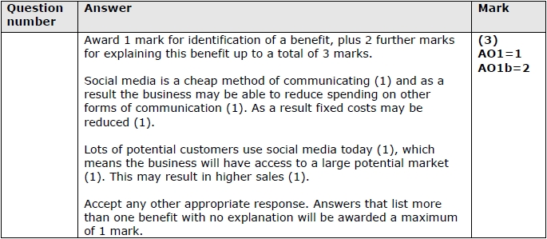

Q10.
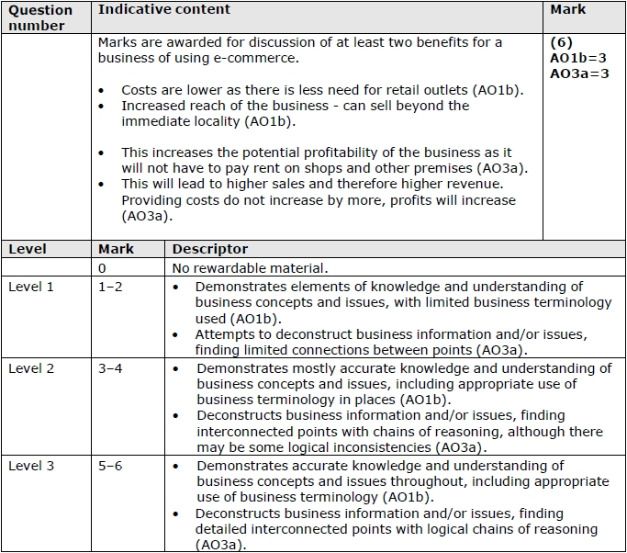

Q11.
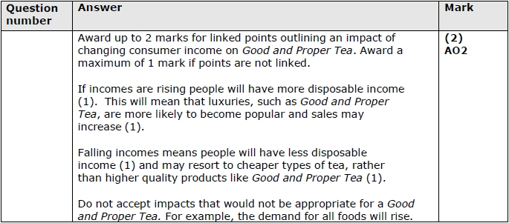

Q12.
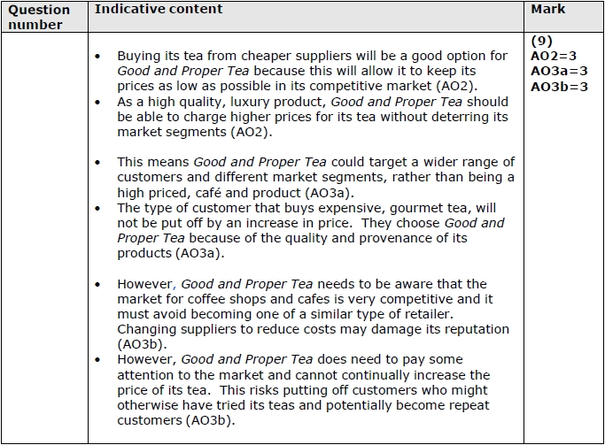
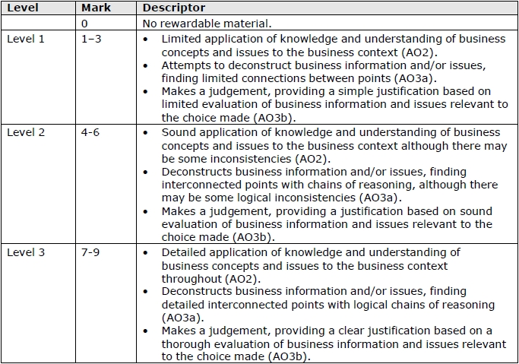

Q13.
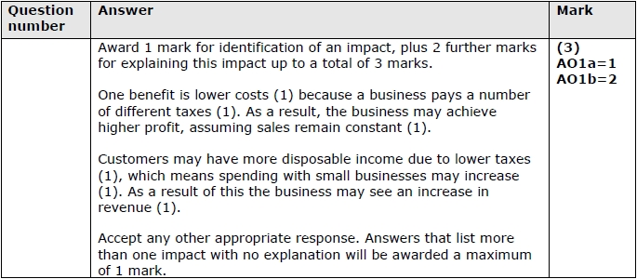

Q14.
