1.3 Questions
Q1.
Answer the question with a cross in the box you think is correct . If you change your mind about an answer, put a line through the box and then mark your new answer with a cross .
Which one of the following is an example of a non-financial objective for an entrepreneur starting a new business?
Select one answer:
(1)
A Survival
B Profit
C Market share
D Independence

(Total for question = 1 mark)

Q2.
Answer the question with a cross in the box you think is correct . If you change your mind about an answer, put a line through the box and then mark your new answer with a cross .
Which one of the following is a financial aim for an entrepreneur when starting a new business?
Select one answer.
A Personal satisfaction
B Independence
C Market share
D Challenge

(Total for question = 1 mark)

Q3.
Answer the question with a cross in the box you think is correct . If you change your mind about an answer, put a line through the box and then mark your new answer with a cross .
Which one of the following is an example of a variable cost?
Select one answer:
(1)
A Rent
B Raw materials
C Insurance
D Advertising

(Total for question = 1 mark)

Q4.
Look at Figures 1 and 2, read the extract carefully, then answer the question.
Neil and Sue have produced the following break even diagram, showing the costs and revenue for their business.
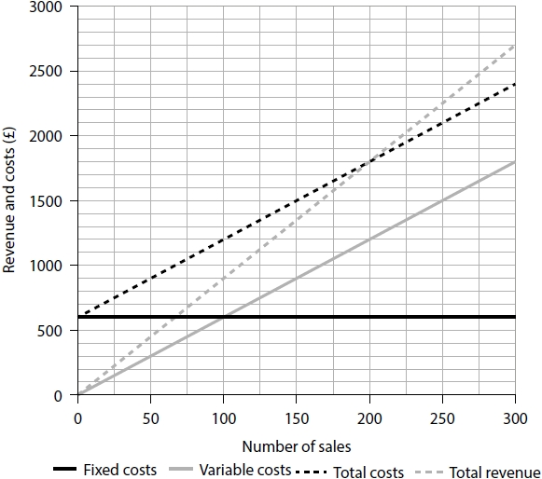
Figure 3
Identify the total number of sales that Neil and Sue will need to break even.
(1)
.............................................................................................................................................

(Total for question = 1 mark)

Q5.
Look at Figures 1 and 2, read the extract carefully, then answer the question.
Neil and Sue have produced the following break even diagram, showing the costs and revenue for their business.
Figure 3
Identify the profit made by Meringue, by shading the correct region of the graph in Figure 3.
(1)

(Total for question = 1 mark)

Q6.
Look at Figures 1 and 2, read the extract carefully, then answer the question.
Neil and Sue have produced the following break even diagram, showing the costs and revenue for their business.
Figure 3
State one benefit to Meringue of having a low break even level of output.
(1)
.............................................................................................................................................
.............................................................................................................................................

(Total for question = 1 mark)

Q7.
Look at Figures 1 and 2, read the extract carefully, then answer the question.
Neil and Sue are considering two options to reduce the amount they need to sell to break even.
Option 1: Increasing average prices by 10%
Option 2: Reducing the cost of ingredients by using a cheaper supplier
Justify which one of these two options Neil and Sue should choose.
(9)
.............................................................................................................................................
.............................................................................................................................................
.............................................................................................................................................
.............................................................................................................................................
.............................................................................................................................................
.............................................................................................................................................
.............................................................................................................................................
.............................................................................................................................................
.............................................................................................................................................
.............................................................................................................................................
.............................................................................................................................................
.............................................................................................................................................
.............................................................................................................................................
.............................................................................................................................................
.............................................................................................................................................
.............................................................................................................................................
.............................................................................................................................................
.............................................................................................................................................

(Total for question = 9 marks)

Q8.
Answer the question with a cross in the box you think is correct . If you change your mind about an answer, put a line through the box and then mark your new answer with a cross .
Which one of the following is a definition of margin of safety?
Select one answer.
A The difference between actual and break even levels of output
B Where total revenue and total costs are equal
C The number of sales required to reach break even
D Profit made above the break even level of output

(Total for question = 1 mark)

Q9.
Read the following extract carefully and then answer the question.
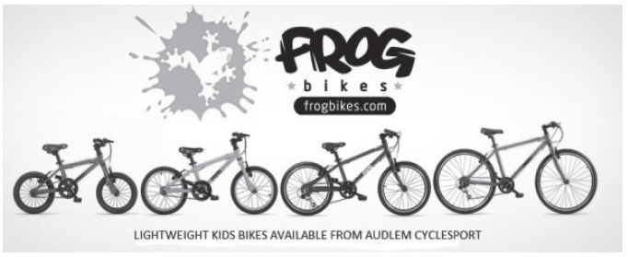
In 2012 Jerry and Shelley Lawson started a new business – Frog Bikes. The aim was to produce lightweight and affordable children's bikes. The company's bikes were designed for children using the latest technology. The bikes are produced in a Chinese factory and sold in the UK and other countries.
The business quickly became successful. By 2016 its bikes were sold in over 700 shops in the UK. It faces competitors such as JE James which sell similar bikes in the UK.
Frog Bikes uses social media to promote its bikes. Figure 2 shows a competition run on the Frog Bikes Twitter account. To enter the competition people needed to follow the business on Twitter.
As a manufacturer and retailer, Frog Bikes has to comply with a large amount of legislation. All bikes meet ISO (International Standards Office) standards. This ensures they are safe for children. Rules include the need for all bikes to be fitted with a chain guard, and for handlebars to be safety checked.
In 2016 Jerry and Shelley decided to increase production to meet the growing demand. They considered expanding the company's Chinese factory, or building a new factory in the UK.
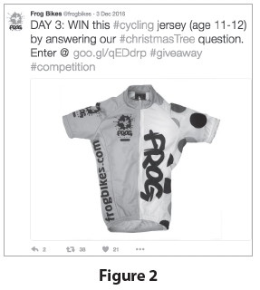
(Source: adapted from http://startups.co.uk/startups-100/2016/8-frog-bikes/)
State one impact on Frog Bikes of having a 'growing demand' for its products.
.............................................................................................................................................
.............................................................................................................................................

(Total for question = 1 mark)

Q10.
Read the following extract carefully and then answer the question.
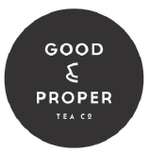
Good and Proper Tea was founded in 2012 by Emilie Holmes. The business website states:
'We source our teas from around the world, from Kenya to India, Japan to China and many more places in between. It is important to us that we know exactly where each tea comes from and who is responsible for harvesting the leaves we buy. We will always share this information with our customers'.
The business started when Emilie converted an old Citroën van (pictured right) into a mobile brew bar. Emilie wanted to expand the business. To achieve this she needed finance.
She decided to raise finance using crowdfunding through the Kickstarter website. 372 individual backers each provided between £1 and £1000. Good and Proper Tea was launched. The first cup of tea was brewed and sold in Shoreditch, London, in 2012.
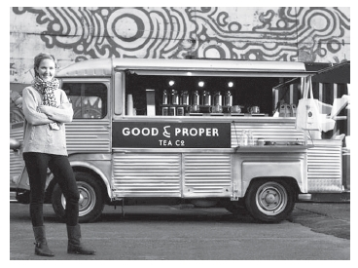
The success of the mobile business led Emilie to plan to open a shop selling the same high-quality teas. Once again she decided to use crowdfunding as her source of finance. This time, using the Crowdcube website, she successfully raised £140,000. The shop was opened in 2016 and is very successful.
As Good and Proper Tea imports its most important ingredient, it is affected by changes in the exchange rate. Recent changes in the value of the pound mean that its costs have increased.
(Source: adapted from http://www.stylist.co.uk/stylist-network/work-life/work-life-emilie-holmes-founder-good-and-proper-tea)
State one example of a fixed cost that Good and Proper Tea needs to pay.
.............................................................................................................................................
.............................................................................................................................................

(Total for question = 1 mark)

Mark Scheme
Q1.

Q2.

Q3.

Q4.

Q5.
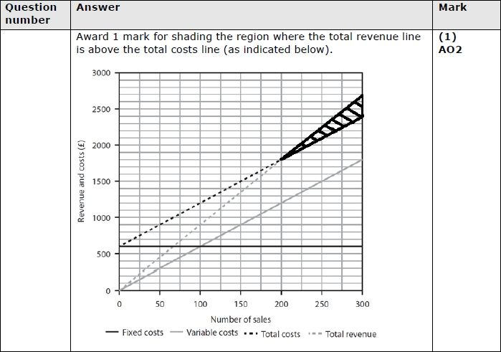

Q6.
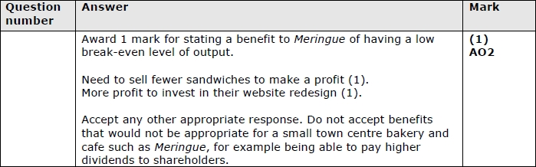

Q7.
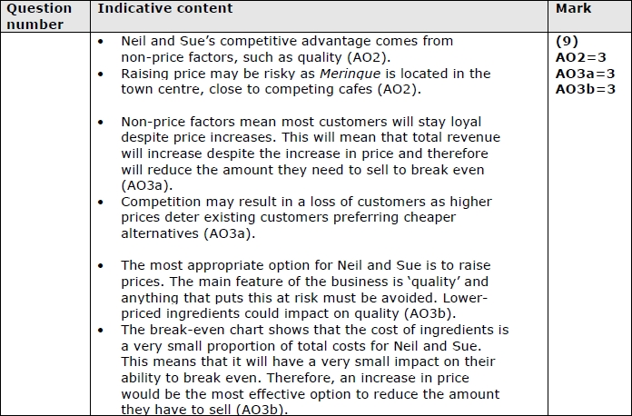
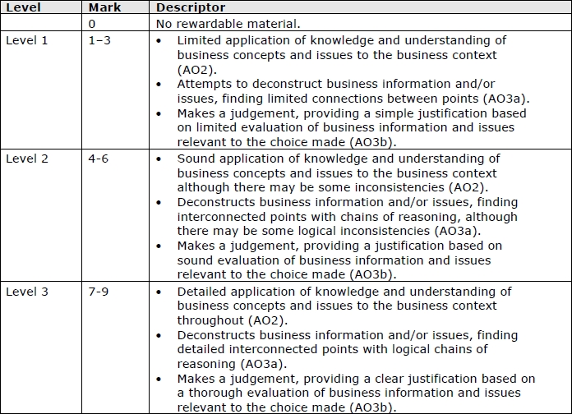

Q8.

Q9.
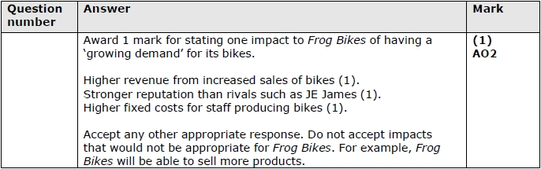

Q10.
